Exercise 1: Inventory Management System
Scenario:
You are developing an inventory management system for a warehouse. Efficient data storage and retrieval are crucial.
Steps:
- Understand the Problem:
  - Explain why data structures and algorithms are essential in handling large inventories.
  - Discuss the types of data structures suitable for this problem.
- Setup:
  - Create a new project for the inventory management system.
- Implementation:
  - Define a class Product with attributes like productId, productName, quantity, and price.
  - Choose an appropriate data structure to store the products (e.g., ArrayList, HashMap).
  - Implement methods to add, update, and delete products from the inventory.
- Analysis:
  - Analyze the time complexity of each operation (add, update, delete) in your chosen data structure.
  - Discuss how you can optimize these operations.
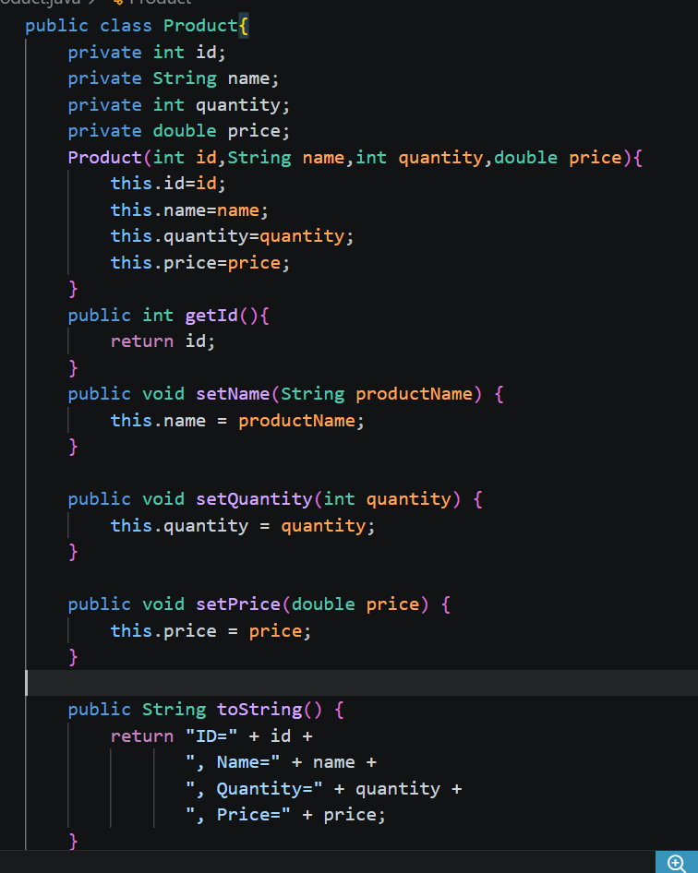
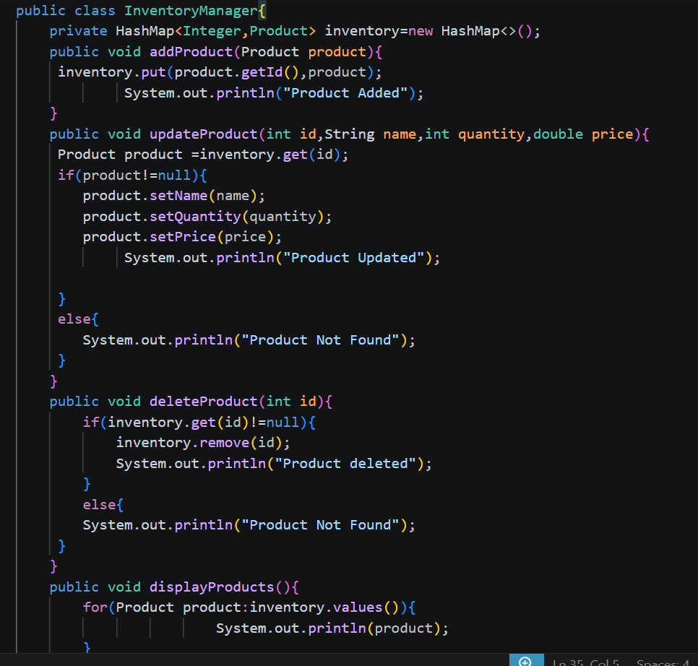
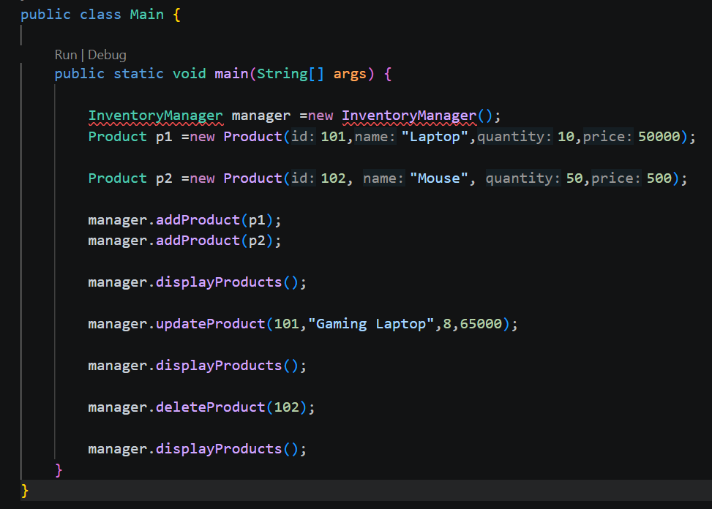
Terminal Output-
